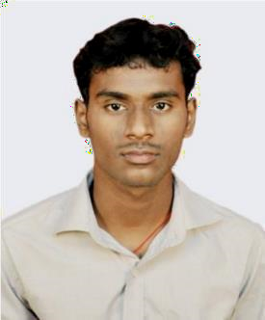
JETTY PRAMOD KUMAR
S/O JETTY GOURI SANKAR RAO
JAYKAYPUR, JKPM COLONY, QR.NO:- E 14/22
RAYAGADA (DIST)-765017, State-ODISHA
E-mail:- pramod.mar18@gmail.com
Mobile: +91-7894183927, 8260651752
CAREER OBJECTIVE:-
- My career objective is updating my skill, knowledge it will helpful for company as a good position in company.
EDUCATIONAL QUALIFICATION:-
- I completed B-Tech degree in 2015 with a steam of Electronics & Instrumentation Engineering (EIE) from school of engineering and technology (JITM), affiliated to CUTM paralakhemundi, Odisha with 80.8%(CGPA).
- I Completed 12th in 2011 from Andhra Pradesh at Vishakhapatnam (Narayana college), affiliated to I.P.E board with 82.9%.
- I Completed 10th in 2009 from Rayagada, Jaykaypur at LPS high School, Odisha affiliated to B.S.E board with 58.6%.

PROJECT WORK:-

    - Minor project on PLC based water tank level controller.

    - Major project on Sensing and displaying the continues weather report.

PERSONAL SKILLS:-

- Good at listening skills.
- Highly motivated and eager to learn new things.

TECHNICAL SKILLS:-

- Knowledge about C, C++, PLC programming and branch related subjects.

EXTRA CURRICULAR ACTIVITIES:-

- Participated in “NATIONAL SEMINAR ON FREE & OPEN SOURCE SOFTWARE-2012” on 5TH & 6TH OCTOBER 2012 at CUTM.
PERSONAL DETAILS:-
- Date of Birth :- 18/12/1993
- Nationality :- Indian
- Sex:- Male
- Languages Known: - English, Hindi, oriya & Telugu

INTERESTS:-

- My interests are watching movie and listening music. I want spent time with my parents. I spend some time for net surfing with my laptop to know the new things.

HOBBIES:-

- Playing chess and cricket.

REFERENCE:-

- Mr. Sandipan pine
- Assistant-professor&HOD
- Dept. of E.I.E, Centurion University, Odisha.
- Email:- sandipan@cutm.ac.in

Mr.Harikristna
        - Lecturer, Dept. of E.I.E, Centurion University, Odisha.

Email:- harikristna@cutm.ac.in

Mobile: +91-9861392486

DECLARATION:-

- I hereby declare that above information is true to the best of my knowledge and belief.

Date:-
Place:-jaykaypur. Signature

